**WEEK 5**

**Creating Microservices for account**

**Code:**

**AccountServiceApplication.java:**

package com.example.accountservice;

import org.springframework.boot.SpringApplication;

import org.springframework.boot.autoconfigure.SpringBootApplication;

@SpringBootApplication

public class AccountServiceApplication {

public static void main(String[] args) {

SpringApplication.*run*(AccountServiceApplication.class, args);

}

}

**AccountController.java:**

package com.example.accountservice;

import org.springframework.web.bind.annotation.GetMapping;

import org.springframework.web.bind.annotation.RestController;

@RestController

public class AccountController {

@GetMapping("/account")

public String getAccountDetails() {

return "Account: Harsshine - Balance: ₹50,000";

}

}

**application.properties:**

server.port=8081

spring.application.name=AccountService

**Output:**

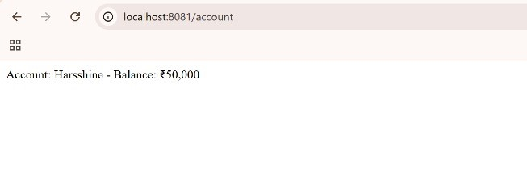**Creating Microservices for Loan**

**Code:**

LoanServiceApplication.java:

package com.example.loanservice;

import org.springframework.boot.SpringApplication;

import org.springframework.boot.autoconfigure.SpringBootApplication;

@SpringBootApplication

public class LoanServiceApplication {

public static void main(String[] args) {

SpringApplication.*run*(LoanServiceApplication.class, args);

}

}

**LoanController.java:**

package com.example.loanservice;

import org.springframework.web.bind.annotation.GetMapping;

import org.springframework.web.bind.annotation.RestController;

@RestController

public class LoanController {

@GetMapping("/loan")

public String getLoanDetails() {

return "Loan: Home Loan - Amount: ₹20,00,000 - Status: Approved";

}

}

**application.properties:**

server.port=8081

spring.application.name=AccountService

**Output:**

